NAME: Gene Matthew T. Aban
Course: BSIT-4
School: Urdaneta City University

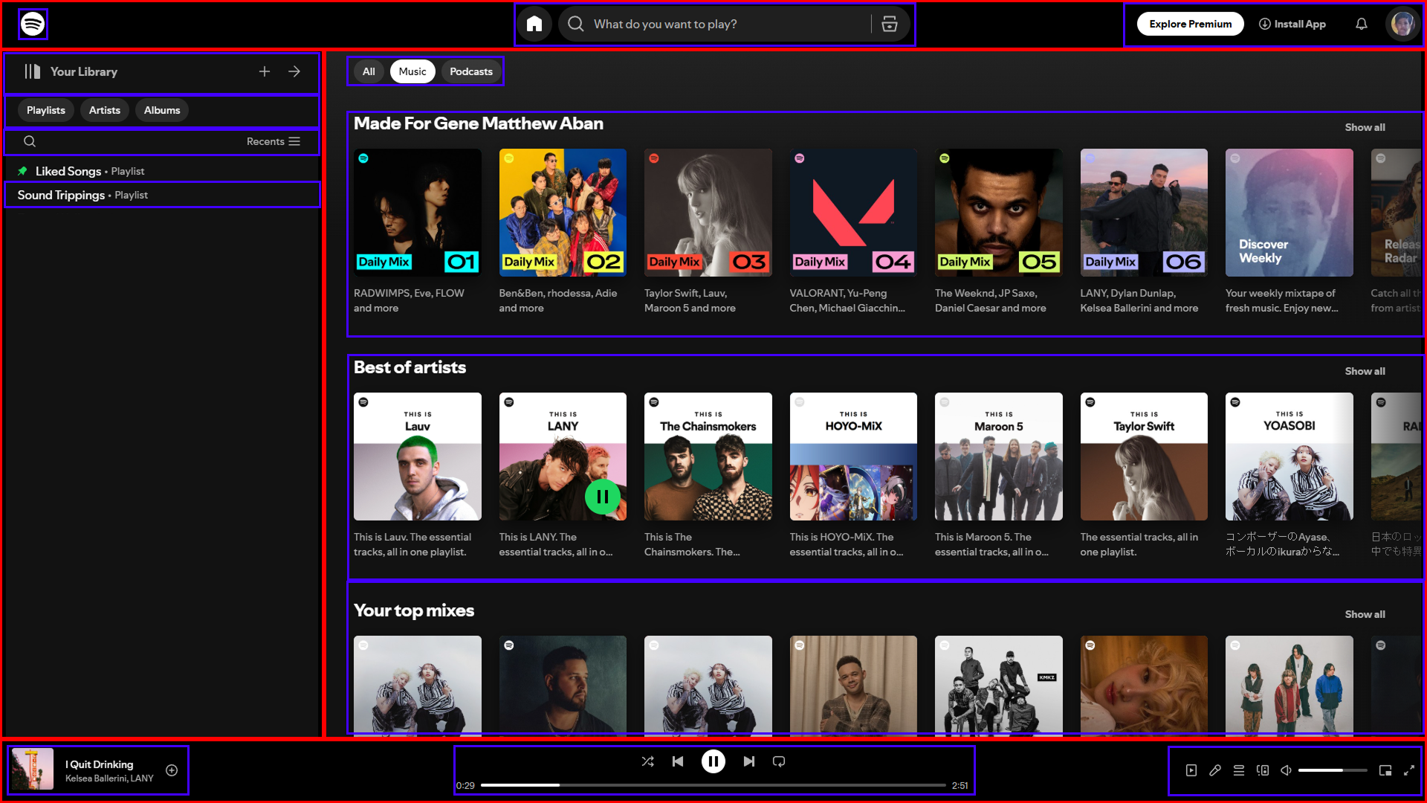

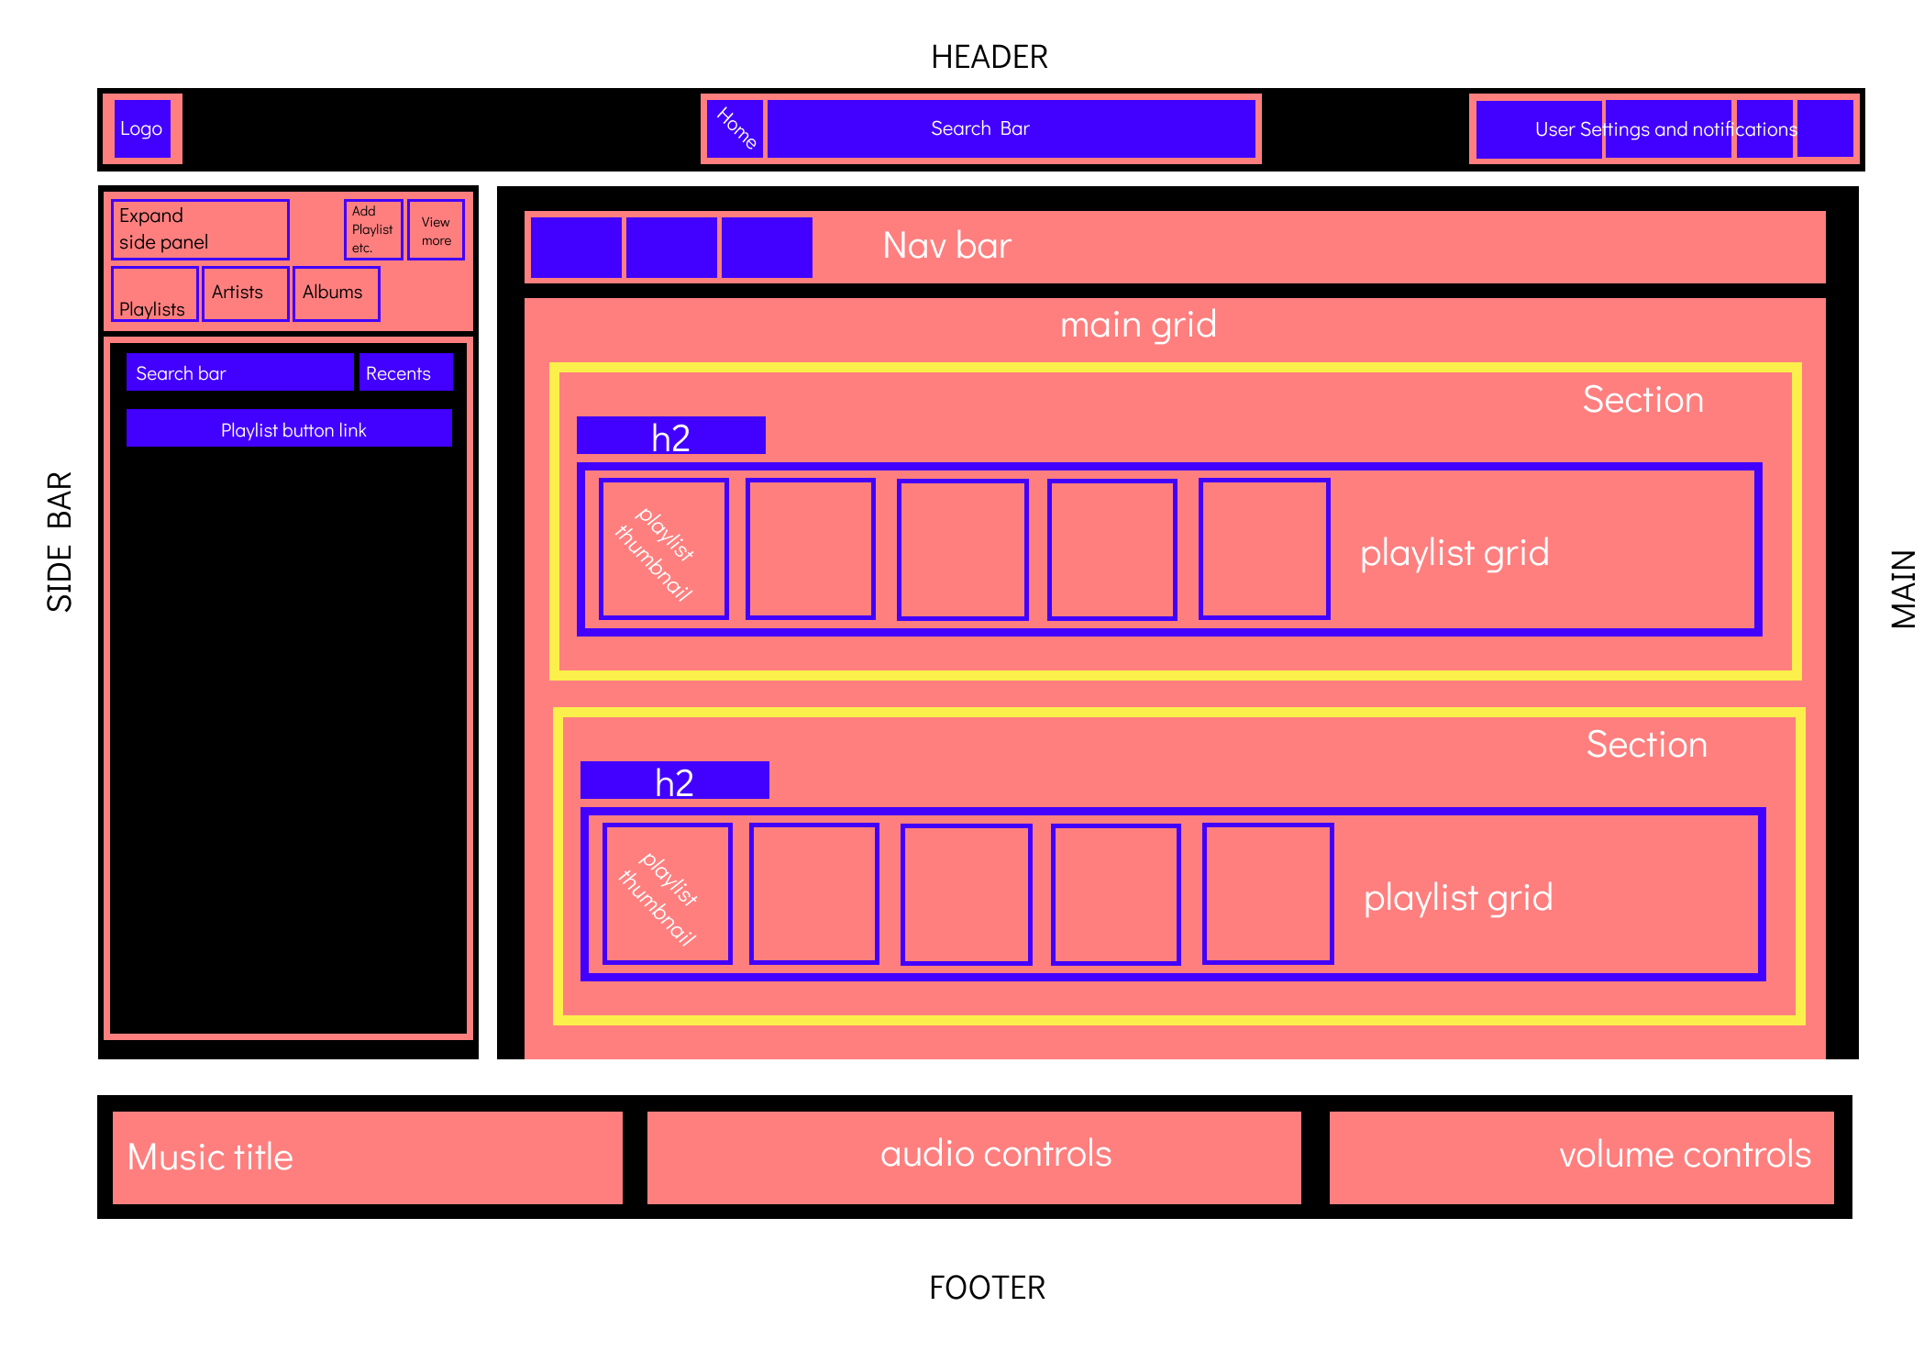

The process and reasoning for breaking down this layout is quite complicate for me.
First is I use the devtools in website, I analyzed the head, body and the footer of spotify . I break it by section because it easier for me to analyze the small elements of each section of the website.

Github repo: https://github.com/sageMuneng/ARMADA-activities

